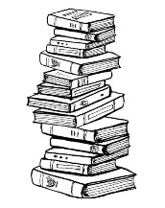
1. Write and say.
Question: _____________________________?
Answer:_______________________________.

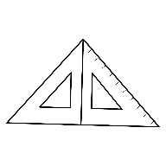
Q: __________________________________?
A: __________________________________.
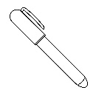
Q: _______________________________?
A: _______________________________.
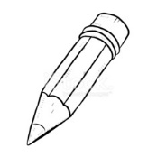
Q: ___________________________________?
A: ___________________________________.

2. Find and translate words.
CLUNE = __________ = __________
ROTBHRE = __________ = __________
RETSIS = __________ = __________
RETOGUDH = ____________ = __________
UNEITA = __________ = __________
OUNISC = __________ = __________

3. Numbers.
35 = thirty – five
61 = ___________________ 48 = ______________________
82 = ___________________ 53 = ______________________
12 = ___________________ 27 = ______________________
96 = ___________________ 19 = ______________________
100 = __________________ 32 = ______________________
4. Match.
Je půl 4. It´s four o´clock.
Jsou 4 hodiny. It´s half past three.
Je čtvrt na 4. It´s quarter past three.
Je třičtvrtě na 4. It´s quarter to four.

